Hate Speech Detection on Twitter: A Comparative Evaluation of Different Machine Learning Techniques

Aryan Rastogi#1, Arjit Kumar*2, Daarshik Dwivedi#3 , Abhishek Pratap Singh#4 , Suruchi Saberwal#5 and Mehboob Alam

*# Computer Science Department, JSS Academy of Technical Education, Noida, Uttar Pradesh, India*

*1 aryanrastogi97@gmail.com*

*2 arjitkumar1802@gmail.com*

*3 daarshikdwivedi10@gmail.com*

*4* [*abhishekpratap218@gmail.com*](mailto:abhishekpratap218@gmail.com)

*5* [*suruchi@jssaten.ac.in*](mailto:suruchi@jssaten.ac.in)

*6 mahboobalam.fet@mriu.edu.in*

Abstract—

The necessity for robust and fast detection techniques has become critical as social media hate speech has grown. This study investigates ways to identify hate speech comments present on Twitter using language processing methods. In this work, we suggest a cutting-edge method for effectively identify hate speech in tweets that combines linguistic elements and machine learning techniques. Using a sizable dataset of annotated tweets, we test our model, and we get good F1-score and accuracy. The findings of this study present the possibilities of using techniques for processing natural language to identify hateful speech on Twitter and can assist in direct the creation of efficient regulations and interventions to lessen the negative consequences of hate speech on social media sites.

Keywords- Twitter , machine learning, tweets, hateful speech

1. Introduction

As we witness the rapid growth of the online ecosystem, we can observe that a large amount of user data is produced every second in the form of images, videos, text posts. This data is commonly generated from social media platforms. The large amount of data generated also includes hate speech between different groups within and across countries to spread prejudices and disputes. Several social media platforms have measures to counter this problem.Twitter's rules state that users cannot use tweets to threaten or harass people as a result of their , gender, race, religion, or any other characteristic. Along with content that is blocked by gender, class, and handicap, YouTube screens information that incites hatred or hostility against specific individuals or groups.

Social media channels like Twitter and Reddit now represent the most popular mediums for the dissemination of hate speech due to their vast user base and ease of use. Twitter and Reddit have 280 million daily active users combined. The anonymity provided by social media can also encourage others to take part in hate speech, as they feel that they can express their views without fear of being made answerable for their deeds. As a result, hateful speech has increased on social media sites, posing a serious problem for online communities.

With such a wide reach of social media channels, the effects of hate spreading speech can be far-reaching, as it can lead to psychological harm, social isolation, and even physical violence. It can also create an atmosphere of fear and intimidation, which can prevent individuals from expressing their views and participating in public discussions. The impact of hate speech can be particularly devastating for vulnerable communities that may already be marginalized and discriminated against.

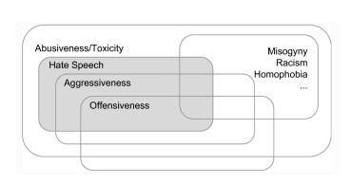

Figure 1: Relationships between abusive language phenomena (source: Poletto et al., 2020).

To combat the rise of hateful speech, many researchers have conducted studies to understand the nature and extent of this problem. Machine learning-based automated hate speech identification systems have attracted increasing attention in recent years. These systems have the potential to identify hate speech and provide early warnings to online communities, thereby reducing the spread of hateful speech.

This study emphasises the critical need for efficient hate speech identification and mitigation on social networks. We want to contribute to the creation of more potent methods for preventing hate speech online by putting forth a unique approach to hate speech identification that combines machine learning algorithms with natural language processing techniques. The findings of this study may influence the creation of automated technologies for identifying hate speech as well as the formulation of regulations and initiatives aimed at fostering more civil and welcoming online communities..

The research paper is organized logically and simply to effectively convey the goals and conclusions of the investigation. A literature review that gives the context and rationale for the investigation is included after the introduction, which introduces the research challenge and motivation for the study. The data sources, preprocessing methods, and models utilized in the experiment are described in the methodology section. The methodology section of the article gives a thorough breakdown of the whole strategy adopted. The study's results are presented in the results section, which is followed by a discussion part that interprets the findings and sheds light on their relevance. The conclusion then emphasizes the research's contributions, summarises the main findings, and offers suggestions for future research. A reference list with a thorough breakdown of the sources used in the study is also included in the publication. Ultimately, the paper's structure is intended to aid the reader's comprehension and involvement with the study.

2. Related Work

Six research articles on the identification of hateful comments posted on social media are compiled in the literature review. Each study approaches the problem of identifying hateful speech using a different strategy or algorithm, employing a variety of datasets and linguistic factors Understanding the methodologies employed in each experiment and identifying the key conclusions and insights of each research publication are the goals of the analysis. In all, we conducted a relevant work survey while taking 10 publications into account.

The influence of extra-linguistic factors on hate speech identification is examined in the first publication [1]. The study examined 16,914 messages for sexist, racist, or neutral content using Twitter data from 614 individuals. Tenfold cross-validation was used with the LR[28] predictor to examine the impact of different features on prediction accuracy. The study discovered that character n-grams up to four characters long, along with demographic data other than gender, produced the greatest outcomes.

The second paper [2] explored the awareness of hate speech among annotators' effects on categorization models. The dataset was obtained by sampling tweets from the 130k tweets extracted by Waseem and Hovy (2016). The features defined by the annotators were evaluated using 5-fold cross-validation to assess the significance of characteristics in groups of novice and experienced annotators. The researchers found that their best-performing system was not able to substantially outperform previous classification efforts.

The significance of fine-grained labeling for hate speech identification is highlighted in the third study [3]. The dataset included 25k tweets that were manually tagged by CrowdFlower staff from a sample of 85.4 million tweets sent by 33k individuals. The resulting model, which had an F1 score of 0.90, a recall of 0.90, and an overall accuracy of 0.91, was an LR[28] using L2 regularisation. The survey did discover that about 40% of hateful speech was misclassified.

The subject of the fourth study [4] was whether or not to label a tweet as racist, sexist, or none. The researchers combined CNN- and LSTM-based architectures with text processing techniques such as TF-IDF[18], char n-grams, and BoWV. The Waseem and Hovy (2016) dataset contained 16 000 annotated tweets. The word TF-IDF approach outperformed the character n-gram approach according to the study, while the CNN model outperformed the LSTM and FastText models.

The fifth study [5] investigated how to automatically detect hate speech while taking context into account. The dataset included 1528 comments from Fox News users, and both machine learning as well as deep learning techniques were taken into account. By include both word-level n-gram features as well as lexicon-derived characteristics, the researchers discovered that the LR[28] method produced good results. Comparing the performance of utilising both ensemble models to using only one model, hate speech detection was substantially enhanced.

The sixth paper [11] focused on identifying misogynous posts in English on Twitter. The dataset consisted of 4000 labeled tweets for training and 1000 unlabelled tweets for testing. The researchers used LR[28], XGBoost, and CatBoost for the classification task and observed that the LR[28] system was the best performer among the model systems evaluated with an accuracy of 70.4%.

Using the "Hate and Abusive Speech on Twitter" dataset, researchers in [12] tested conventional machine learning models versus neural network models to detect abusive language. The findings demonstrated that among models based on neural networks, RNNs with LTC modules had the highest accuracy ratings, while the LR[28] was the most effective conventional model. The most trustworthy outcomes were provided by bidirectional GRU networks incorporating LTC.

In [13], researchers used a transfer learning methodology in conjunction with the supervised fine-tuning and unsupervised pre-trained BERT model methods to identify hate speech. They utilized [1] and [3] datasets, which included 25k tweets from unbalanced groups. Utilizing a batch size of 32 for three training epochs as well as a dropout layer probability of 0.1 for all layers, the BERT model, text tokenizer, and WordPiece were used. A 2e-5 learning rate was used while using the Adam optimizer. F1 scores for BERT-based techniques were higher than baselines, while the addition of a CNN to the BERT model gave the greatest outcomes, with F1 scores for the Waseem and Davidson datasets of 88% and 92%, respectively.

In [14] researchers present a database that focuses on analyzing various aspects of hate speech. The dataset consisted of 20,000 posts collected from Twitter and Gab. Each post was physically annotated by multiple annotators, and the labels were chosen by a qualified majority. The resulting dataset provides a new benchmark for hate speech detection, with each data point labeled as offensive, normal, or hate, along with providing details about the target population and highlighted text passages that support the label. However, the study did not consider demographic data that could have been useful for annotating the data, and only English language data was used.

In contrast, academics analyzed large-scale multilingual hate speech in 9 languages from 16 sources [15]. They trained models in multilingual environments using multilingual embeddings for words and sentences, such as LASER and MUSE. They evaluated different combinations of models such as BERT, mBERT, CNN+GRU, LASER+LR, MUSE+CNN-GRU, and Translation+BERT for the detection of hate speech. They found that BERT models performed better in high-resource scenarios than LASER+LR in low-resource situations. LASER+LR performed better than MUSE+CNN-GRU in most cases. They also discovered that there wasn't a one-size-fits-all solution, but Translation+BERT seemed to be an excellent compromise. In zero-shot analysis, mBERT outperformed LASER+LR significantly in three languages (Arabic, French, and German), while LASER+LR performed better than mBERT in Portuguese and Italian. In general, LASER+LR outperformed mBERT in low-resource situations for most languages. However, for high-resource situations, mBERT scored higher than LASER+LR for German, Arabic, and French. LASER+LR consistently delivered excellent results for Portuguese.

Overall, the literature review shows that researchers have employed a variety of techniques to help solve the issue of detecting social media hateful speech. While some studies focused on the impact of extra-linguistic features and fine-grained labels, others explored the use of context information and different text processing algorithms with machine learning and deep learning models. The studies' findings indicate that the problem of hate speech detection remains challenging, with misclassification rates ranging from 40% to 70.4%. The studies suggest that further research is necessary to help solve the issue of detecting hate speech .and to improve the models' accuracy and performance.

3. Methodology

The suggested technique used to categorize tweets into two groups—"hate speech and non-hate speech"—is explained in this section. The whole research technique is shown in Fig. 2. Data collection, data preprocessing, feature engineering, data splitting, base model creation, best base model selection, hyperparameter tuning of selected models, and classification model assessment are the eight main procedures for the research methodology as indicated in this image. In the sections that follow, each process is covered in full.

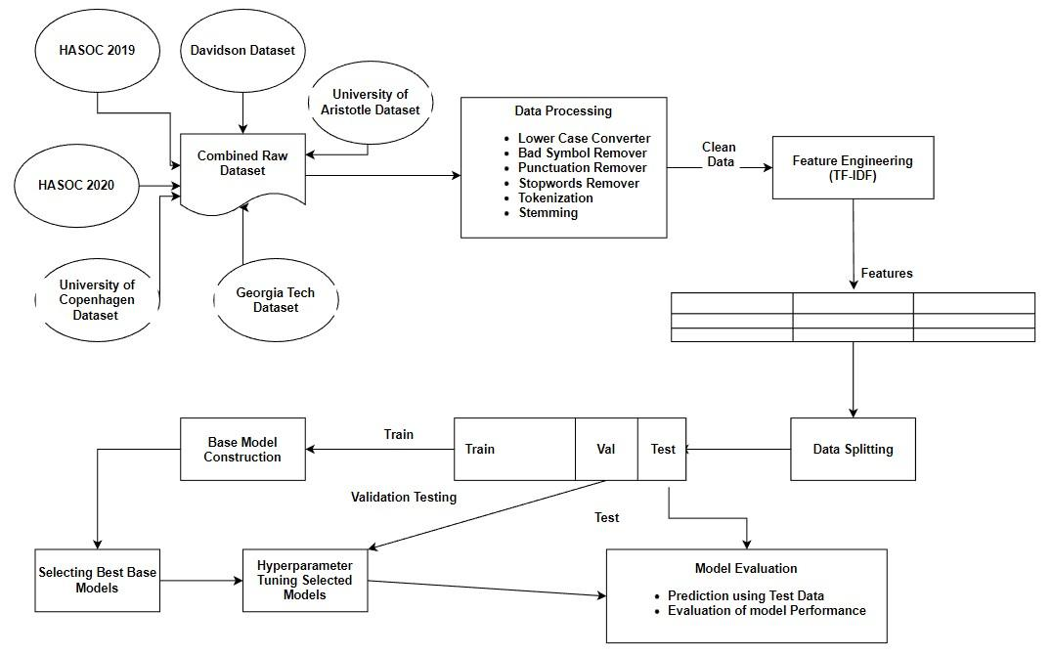

Figure 2: System Design

1. *Data Collection*

For this study, we gathered a dataset of hate speech tweets that were made publicly available. The University of Aristotle Hate Speech Dataset, University of Copenhagen Hate Speech Dataset, HASOC 2019, HASOC 2020, and Georgia Tech Dataset were combined with the Davidson Dataset to create this dataset. The tweets in the merged dataset are categorised into two separate groups., namely hate speech and non-hate speech. There are 30270 tweets in this dataset. Of these, 22.9% of tweets fall under the category of hate speech, while 77.1% fall under the category of non-hate speech.

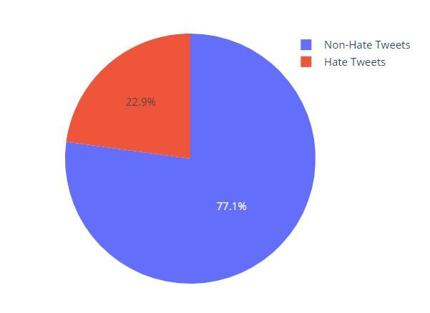

Figure 3: Class Distribution of combined dataset

Table 1: Datasets used

| **Name of Dataset** | **Detail of Instances Used** |
| --- | --- |
| Davisdon Dataset[24] | Non-hate tweets: 23353 Hate Tweets count: 1430 |
| University of Aristotle Hate Speech Dataset[20] | 1614 Hate Speech Tweets used |
| University of Copenhagen Hate Speech Dataset[1] | 2684 Hate Speech Tweets used |
| HASOC 2019 [21] | 58 Hate Speech Tweets used |
| HASOC 2020 [22] | 131 Hate Speech Tweets used |
| Georgia Tech Hate Speech Dataset [23] | 1500 Hate Speech Tweets used |

1. *Text Processing*

Several research studies have explained that using text preprocessing makes better classification results [17]. So, in our dataset, we applied different preprocessing techniques to filter noisy and non-informative features from the tweets. In preprocessing, we changed the tweets into lowercase. Also, we removed all the URLs, usernames, white spaces, hashtags, punctuations, and stop-words using pattern-matching techniques from the collected tweets. In addition, we have carried out tokenization using preprocessed tweets. Each tweet is first tokenized into words or tokens, and then words are further transformed by the Porter stemmer into their root forms, such as offended to offend.

1. *Feature Engineering*

The categorization criteria from the raw text are incomprehensible to machine learning systems. For these algorithms to comprehend categorization rules, numerical characteristics are required. Hence, feature engineering is a crucial stage in text categorization. The primary features from the raw text are retrieved in this stage, and the characteristics are then represented numerically. In this inquiry, TF-IDF [18] has been utilized as a feature engineering technique.

1. *Exploratory Data Analysis*

Any research concerning hate speech must use exploratory data analysis (EDA). EDA includes looking at the data to find outliers, trends, and patterns. It enables researchers to comprehend the data's features more thoroughly and to spot any problems or biases that could exist. In the context of research on hate speech, EDA may entail determining the frequency and distribution of hate speech across various demographic groups, identifying the terminology or expressions that are most often used in hate speech, and assessing the environment in which hate speech is expressed. Examining the connections between hate speech and other factors, including the frequency of hate crimes or the usage of hate speech in political discourse, may also be part of EDA. Ultimately, EDA is a crucial instrument for understanding the type and extent of hate speech and for guiding the creation of successful solutions to this issue.

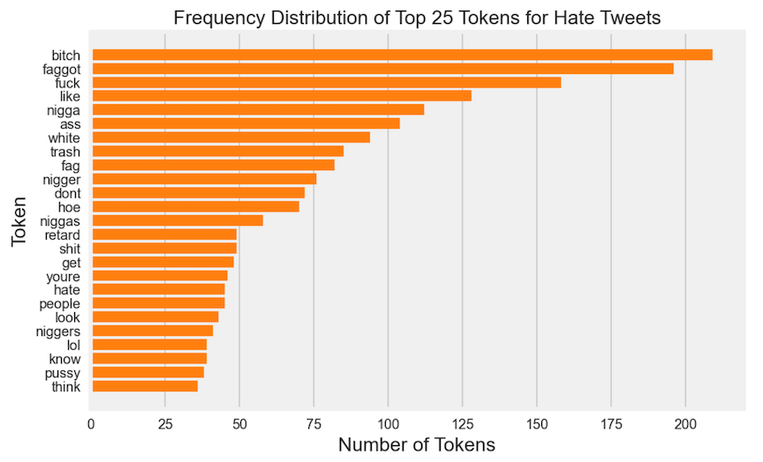

Figure 4: Frequency distribution of top 25 Tokens for Hate Tweets

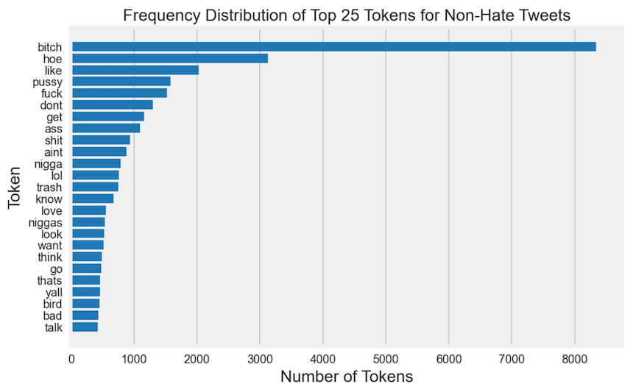

Figure 5: Frequency distribution of top 25 Tokens for Non-Hate Tweets

There are common terms and expressions used in both forms of communication, according to an exploratory examination of the top 25 words in both the Hate and Non-Hate categories. This demonstrated that the vocabulary used to communicate hate speech and non-hate speech are not fundamentally dissimilar. It also implied that some of the most popular terms in everyday speech may be appropriated and used to spread hate. This reinforced the necessity of supporting civil discourse and excellent communication in addition to monitoring hate speech in hopes of preventing the propagation of hate expression through social media.

1. *Data Splitting*

Table 2 displays the whole dataset's class-wise distribution as well as the data set following splitting (i.e. Training set, Validation set, and Test set). To divide the preprocessed data into training and validation sets, we utilized a 75:25 ratio, or 75% for training and 25% for validation. To create the test data, the validation dataset was once more divided in half using a 60:40 ratio. To learn the rule base, the classification model has to be trained using data for training. To evaluate the model's effectiveness, the validation data is used. Using test data on hypothetical scenarios, the categorization model is also assessed.

Table 2: Data Split

|  | Class Label | Total Instances | Training Instances | Validation Instances | Testing Instances |
| --- | --- | --- | --- | --- | --- |
| 0 | Non-Hate Tweets | 23353 | 17514 | 3503 | 2336 |
| 1 | Hate Tweets | 7417 | 5562 | 1113 | 742 |

1. *Machine Learning Models*

It is thought that there isn't a single classifier that excels on all types of datasets when applying machine learning to a task. As a result, it is advised to test a variety of classifiers on a master feature vector to see which produces the best outcomes. So, we chose the Multinomial Naive Bayes, LR [28], SVM [26], RF [25], Adaboost [27], and GBDT as our six distinct classifiers.

1. *Classifier Evaluation*

This phase involves utilizing the test set to predict the class of unlabeled text using the created classifier. The generated classifier's performance is evaluated using a variety of performance indicators. This is a quick discussion of a few standard text classification performance metrics.

1) Precision: Another name for precision is the positive projected value. It is the percentage of predicted positives that really turn out to be positive. Equation (1) summarizes the precision calculation formula.

(1)

2) Recall: The percent measure of favorable outcomes that actually occur and are anticipated to occur. Observe "(2)."

(2)

3) F1 Score: It represents the harmonic mean of recall and accuracy (as shown in Equation 3). Precision and recall are given equal weight in the standard F1 Score. Equation (3) presents the formula to calculate f1 score.

(3)

4) Accuracy: It is the number of cases that were appropriately categorized. The formula is given in equation (4).

(4)

5. Experimental Observations

We have trained our aggregated datasets on six classifiers and the model training and testing results and shown in below mentioned table. Further to this, the hyperparameter tuning of these classifiers has been performed using GridSearchCV to obtain optimal parameters and again the model training and testing results have been evaluated and presented in table 4.

Table 3: Base Model Testing Results

|  | **Accuracy** | **F1 Score** | **Recall** | **Precision** |
| --- | --- | --- | --- | --- |
| **Multinominal Naive Bayes** | 0.86 3548 | 0.611111 | 0.44744 | 0.976331 |
| **Random Forest[25]** | 0.882716 | 0.698413 | 0.563342 | 0.918681 |
| **Logistic Regression[28]** | 0.892788 | 0.743390 | 0.644205 | 0.878676 |
| **Support Vector Machine[26]** | 0.901884 | 0.779240 | 0.718329 | 0.851438 |
| **Adaboost Classifier[27]** | 0.885965 | 0.738645 | 0.668464 | 0.825291 |
| **Gradient Boosting Classifier** | 0.878493 | 0.673647 | 0.520216 | 0.955446 |

Table 4: Hyperparameter Tuned Model Results

|  | **Accuracy** | **F1 Score** | **Recall** | **Precision** |
| --- | --- | --- | --- | --- |
| **Logistic Regression w/GridsearchCV[28]** | 0.917894 | 0.820634 | 0.778976 | 0.867000 |
| **Random Forest w/GridsearchCV[25]** | 0.895364 | 0.731219 | 0.590296 | 0.960526 |
| **Support Vector Machine w/GridsearchCV[26]** | 0.922227 | 0.828640 | 0.77987 | 0.883910 |

In terms of F1-score, accuracy, and recall, a comparison of the results in Tables 3 and 4 revealed that the hyperparameter tweaked models performed much better than the basic models. The greatest F1 score was 0.820634 for the LR[28] approach using GridsearchCV, with recall and precision values of 0.778976 and 0.867000, respectively. Similar to how the SVM model with GridsearchCV worked well, with an F1 score of 0.828640, recall of 0.77987, and accuracy of 0.883910, it likewise performed well. Our findings highlight the significance of hyperparameter optimization in hate speech identification as it may greatly enhance model performance.

The performance of the base models, on the other hand, varied. With an F1 score of 0.611111, the multinominal Naive Bayes model performed poorly in terms of detecting instances of hate speech. The RF[25] model fared better, earning an F1 score of 0.698413, but its recall was still just 0.563342, which was not particularly high. The gradient boosting classifier demonstrated the trade-off between accuracy and recall by having the highest precision (0.955446), but also the lowest recall (0.520216).

Overall, our findings highlight the utility of hyperparameter tweaking in enhancing model performance as well as the necessity of prioritizing F1 score, precision, and recall above accuracy in hate speech identification.

6. Conclusion

The investigation leads to the conclusion that detecting hateful speech is a difficult undertaking, especially when working with unbalanced datasets. A dataset comprising about 22k non-hate tweets and 8k hate tweets was produced for the study by combining hate and non-hate tweets.

Using default settings, the performance of six binary classification models was assessed. It was found that the SVM[26] model, which had an accuracy of 90.19%, was the most accurate, followed by Logistic Regression, which had an accuracy of 89.28%. It was pointed out, nonetheless, that accuracy is not the ideal statistic to assess a model's performance with an unbalanced dataset.

The F1 Score, Recall, and Precision results indicated that the SVM model performed superior to the other models. The model obtained F1 scores of 0.779, 0.718 for recall, and 0.851 for precision. Also, it was discovered that the SVM model's performance greatly increased following hyperparameter adjustment, with an F1 Score of 0.829, Recall of 0.780, and Precision of 0.884.

In conclusion, the study contends that SVM , particularly when working with unbalanced datasets, is a viable model for the detection of hateful speech on social media. While assessing the model's performance on an unbalanced dataset, it is critical to place an emphasis on measures like F1 Score, Recall, and Precision rather than accuracy.

7. References

1. Waseem, Z., & Hovy, D. (2016). Hateful Symbols or Hateful People? Predictive Features for Hate Speech Detection on Twitter. North American Chapter of the Association for Computational Linguistics.
2. Zeerak Waseem. 2016. Are You a Racist or Am I Seeing Things? Annotator Influence on Hate Speech Detection on Twitter. In Proceedings of the First Workshop on NLP and Computational Social Science, pages 138–142, Austin, Texas. Association for Computational Linguistics.
3. Davidson, T., Warmsley, D., Macy, M.W., & Weber, I. (2017). Automated Hate Speech Detection and the Problem of Offensive Language. International Conference on Web and Social Media.
4. Badjatiya, P., Gupta, S., Gupta, M., & Varma, V. (2017). Deep Learning for Hate Speech Detection in Tweets. Proceedings of the 26th International Conference on World Wide Web Companion.
5. Gao, L., & Huang, R. (2017). Detecting Online Hate Speech Using Context Aware Models. Recent Advances in Natural Language Processing.
6. Kumar A, Jaiswal A. Systematic literature review of sentiment analysis on Twitter using soft computing techniques. Concurrency and Computation: Practice and Experience. 2020 Jan 10;32(1):e5107.
7. Poletto F, Basile V, Sanguinetti M, Bosco C, Patti V. Resources and benchmark corpora for hate speech detection: a systematic review. Language Resources and Evaluation. 2020 Sep 30:1-47.
8. Anam MC, Hafiz M. Surat Edaran Kapolri Tentang Penanganan Ujaran Kebencian (Hate Speech) dalam Kerangka Hak Asasi Manusia. Jurnal Keamanan Nasional. 2015 Dec 28;1(3):341-64.
9. Nobata C, Tetreault J, Thomas A, Mehdad Y, Chang Y. Abusive language detection in online user content. InProceedings of the 25th international conference on world wide web 2016 Apr 11 (pp. 145-153).
10. Hayaty M, Adi S, Hartanto AD. Lexicon-Based Indonesian Local Language Abusive Words Dictionary to Detect Hate Speech in Social Media. Journal of Information Systems Engineering and Business Intelligence. 2020 Apr 27;6(1):9-17.
11. Saha, P., Mathew, B., Goyal, P., & Mukherjee, A. (2018). Hateminers : Detecting Hate speech against Women. ArXiv, abs/1812.06700.
12. Younghun Lee, Seunghyun Yoon, and Kyomin Jung. 2018. Comparative Studies of Detecting Abusive Language on Twitter. In Proceedings of the 2nd Workshop on Abusive Language Online (ALW2), pages 101–106, Brussels, Belgium. Association for Computational Linguistics.
13. Mozafari, M., Farahbakhsh, R., Crespi, N. (2020). A BERT-Based Transfer Learning Approach for Hate Speech Detection in Online Social Media. In: Cherifi, H., Gaito, S., Mendes, J., Moro, E., Rocha, L. (eds) Complex Networks and Their Applications VIII. COMPLEX NETWORKS 2019. Studies in Computational Intelligence, vol 881. Springer, Cham.
14. Binny, Mathew., Punyajoy, Saha., Seid, Muhie, Yimam., Chris, Biemann., Pawan, Goyal., Animesh, Mukherjee. (2020). HateXplain: A Benchmark Dataset for Explainable Hate Speech Detection. arXiv: Computation and Language,
15. Aluru, S.S., Mathew, B., Saha, P., & Mukherjee, A. (2020). Deep Learning Models for Multilingual Hate Speech Detection. ArXiv, abs/2004.06465.
16. Caselli, T., Basile, V., Mitrovic, J., & Granitzer, M. (2021). HateBERT: Retraining BERT for Abusive Language Detection in English. ArXiv, abs/2010.12472.
17. Dutta, S., Caur, S., Chakrabarti, S., & Chakraborty, T. (2022). Semi-supervised Stance Detection of Tweets Via Distant Network Supervision. Proceedings of the Fifteenth ACM International Conference on Web Search and Data Mining.
18. Shaikh, S. and S.M. Doudpotta, Aspects Based Opinion Mining for Teacher and Course Evaluation. Sukkur IBA Journal of Computing and Mathematical Sciences, 2019. 3(1): p. 34-43.
19. Ramos, J. Using tf-idf to determine word relevance in document queries. in Proceedings of the first instructional conference on machine learning. 2003. Piscataway, NJ.
20. Founta, A., Djouvas, C., Chatzakou, D., Leontiadis, I., Blackburn, J., Stringhini, G., Vakali, A., Sirivianos, M. and Kourtellis, N., 2018. Large Scale Crowdsourcing and Characterization of Twitter Abusive Behavior
21. Mandl, T., Jain, R., Illa, M., Zampieri, M., & Bhardwaj, A. (2019). Overview of the HASOC track at FIRE 2019: Hate Speech and Offensive Content Identification in Indo-European Languages. In Working Notes Proceedings of the Conference and Labs of the Evaluation Forum (CLEF) (Vol. 2380). CEUR-WS.org.
22. Mandl, T., Goyal, P., Jain, R., Illa, M., Zampieri, M., & Bhardwaj, A. (2020). Overview of the HASOC track at FIRE 2020: Hate Speech and Offensive Content Identification in Indo-European Languages. In Working Notes Proceedings of the Conference and Labs of the Evaluation Forum (CLEF) (Vol. 2696). CEUR-WS.org.
23. Banda, J. M., Tekumalla, R., Abrahao, B., Al-Garadi, M. A., & Lewis, D. (2020). COVID-19 misinformation detection using sparse deep learning models. Applied Intelligence, 1-15.
24. Banda, J. M., Tekumalla, R., Abrahao, B., Al-Garadi, M. A., & Lewis, D. (2020). COVID-19 misinformation detection using sparse deep learning models. Applied Intelligence, 1-15.
25. Xu, B., et al., An Improved Random Forest Classifier for Text Categorization. JCP, 2012. 7(12): p. 2913-2920.
26. Joachims, T. Text categorization with support vector machines: Learning with many relevant features. in European conference on machine learning. 1998. Springer
27. Ying, C., et al., Advance and prospects of AdaBoost algorithm. Acta Automatica Sinica, 2013. 39(6): p. 745-758.
28. Wenando, F.A., T.B. Adji, and I. Ardiyanto, Text classification to detect student level of understanding in prior knowledge activation process. Advanced Science Letters, 2017. 23(3): p. 2285-2287.